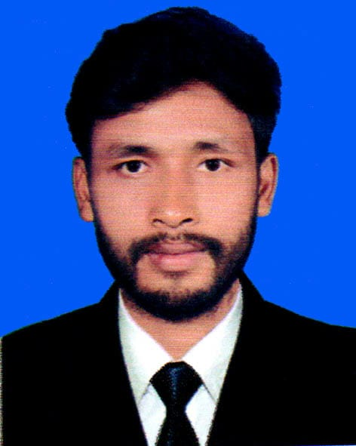**Sompod Ray**  
Kanchan para, porar hat Nilphamari sadar  
Nilphamari, 5300  
Phone - 01740478229  
Email - apurbonil2626@gmail.com

Github - https://github.com/sompod22

Linkedin - [https://www.linkedin.com/in/sompod-ray-821523214](https://www.linkedin.com/in/sompod-ray-821523214?trk=contact-info)

Fiverr - https://www.fiverr.com/sompod_ray

**Objective**

To pursue a career with most exposure in growth oriented corporate environment to secure a position that provides sufficient challenge and freedom with a scope of utilizing textual and practical ‘knowledge’ individual and originality; to accomplish the organization’s mission.

**Education**

HSC  
Higher Secondary Certificate  
2020

**Training**

**Computer Fundamentals and Office Applications Training**  
Organized by Bangladesh Computer Council and Center for Digital Transformation (CDT), Begum Rokeya University, Rangpur  
Funded by Enhancing Digital Government & Economy (EDGE) Project  
Year of Completion - 2025

* Gained proficiency in basic computer operations and Microsoft Office applications.
* Hands-on experience with tools like Word, Excel, PowerPoint, and others.
* Learned essential skills for digital government services and economic applications.

**Technical Skills**

* **Office Applications**: Microsoft Word, Excel, PowerPoint
* **Computer Fundamentals**: Hardware and software basics, troubleshooting
* Proficient in Microsoft Office Suite (Word, Excel, PowerPoint, Outlook)
* Basic computer troubleshooting
* Understanding of digital government services
* Strong attention to detail and organizational skills
* Excellent communication and teamwork abilities

**Projects:**

**Academic Marksheet**

I make an academic mark-sheet using MS Office 2016.

**Salary Sheet**

I make an academic mark-sheet using MS Office Excel 2016.

**Hostel Maintenance Sheet**

I make a Hostel Maintenance Sheet using MS Office Excel 2016

**Biography Presentation**

I make a biography presentation using MS Office PowerPoint 2016

**Certifications**

* **Computer Fundamentals and Office Applications Training**

**Languages**

* English (Fluent)
* Bangla (Fluent)

**References**

**Reference: 01**

Name - Md Yousuf Ali

Organization - Nilphamari Govt College

Designation - Lecturer Of ICT

**Reference: 02**

Name - Md. Jahangir Alam

Organization - Nilphamari Govt College

Designation - Associate Professor Of Chemistry